 | International Civil Aviation Organization  WORKING PAPER
  ACP-WG I-06/IP-04
  3/19/2008

Aeronautical Communication Panel
Working Group I – Internet Protocol Suite (IPS)

March 17-20, 2008
Montreal, Canada

IP Mobility Management
in
3GPP2 Networks

Prepared by: Tom McParland

SUMMARY

This paper describes IP mobility management as specified for the 3rd Generation Partnership Project 2 (3GPP2) Converged Access Network.

1. Introduction

Several Standards Development Organizations (SDOs) are attempting to define next generation wireless network architectures which are IP-based and which employ various mobility management schemes. The principle SDOs are the Internet Engineering Task Force (IETF); the Worldwide Interoperability for Microwave Access (WiMax) Forum, which is developing specifications based on the IEEE 802.16 standards; the 3rd Generation Partnership Project (3GPP), which develops specifications based on evolved Global System for Mobile Communications (GSM) specifications; and the 3rd Generation Partnership Project 2 (3GPP2), which develops specifications based on evolved IS-95 (CDMA) specifications. These SDOs have generally selected two approaches for mobility: Mobile IP (MIP), also known as Client Mobile IP (CMIP) and Proxy Mobile IP (PMIP).
This paper first provides a generic network reference architecture which describes the general use of MIP and PMIP mobility management (MM). This paper then describes IP mobility for 3GPP2. More specifically, this paper describes the architecture and operation of the Converged Access Network as specified in the 3GPP2 X.S0054 series of specifications.

2. mobile ip (MIP) and PROXY Mobile IP (PMIP)

Client Mobile IPv4 (CMIP4) is specified in [RFC 3344] and Client Mobile IPv6 (CMIP6) is specified in [RFC 3775]. Proxy Mobile IPv4 (PMIP4) is specified in [mip4-proxy-mode] and Proxy Mobile IPv6 (PMIP6) is specified in [proxymip6].
Mobile IP and Proxy Mobile IP can be configured in various combinations for operation in a topologically distributed fashion whereby the visited network is distinguished from the home network. In this situation the visited network has a local mobility anchor (LMA) also called a mobility anchor point (MAP) and the home network has a home agent (HA). These entities support location management, that is, they keep track of the movement of a mobile node and locate the mobile node for data delivery in the visited or home network. The visited and home networks have a heirarichal relationship. Figure 1 depicts the possible configrations.

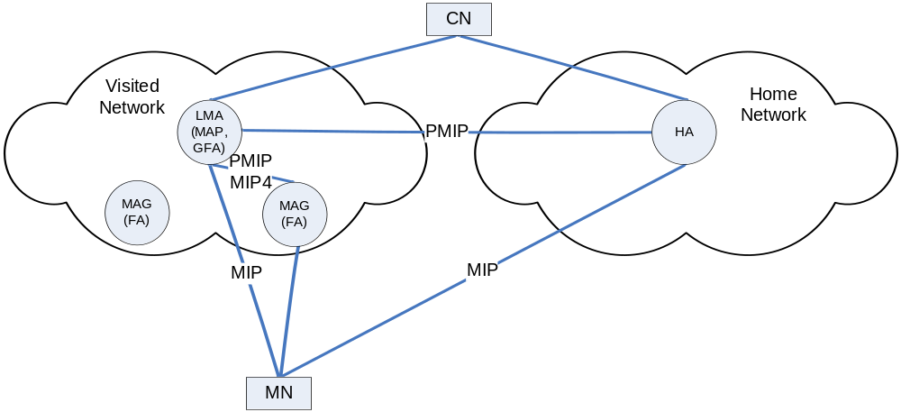

Figure 1 – Mobile IP and Proxy Mobile IP in a Home and Visited Network

There are three generic combinations of local and global mobility.

Scenario 1 - MIP as the Local MM Protocol and the Global MM Protocol

Mobility signalling to the home agent may be performed by the mobile node. There are two cases where this occurs. One is with Heirarichical Mobile IP (HMIP) [reg-tunnel,RFC 4140]. In the IPv6 case the MN sends binding updates to both the LMA and to the HA. In the IPv4 variation of HMIP the Foreign Agent (FA) on behalf of the MN sends updates to a Gateway Foreign Agent (GFA) and the HA. In this case MIP is both the local and global MM protocol.

Scenario 2 - PMIP as the Local MM Protocol and MIP as the Global MM Protocol

Another is where the MN only sends updates to the HA and updates to the LMA are sent by mobile access gateways (MAG) on behalf of the MN in the visited network [netlmm-mip-interactions]. In this case PMIP is the local MM protocol and MIP is the global MM protocol.

Scenario 3 - PMIP as the Local MM Protocol and the Global MM Protocol

Mobility signalling to the home agent may alternatively be sent by the LMA to the HA using PMIP. Examples of this operation occur in 3GPP roaming scenarios [3GPP TS 23.402] where a MAG in a non-3GPP network connects to a serving gateway in a visited 3GPP network using PMIP which in turn connects to the HA in the home network. In this case PMIP is both the local and global MM protocol.

Note that non-heirarchical topologies are possible, for example, there may only be a home network which is geographically distributed with multiple HAs. In this case it is possible to operate a separate protocol between the HAs such as the Global HA to HA protocol [global-haha]. These options are not considered in this paper.

3. IP MOBILITY IN 3gpp2

3.1 IP Mobility

Figure 2 depicts the IP mobility flows from the 3GPP2 Converged Access Network (CAN) Architecture for the roaming scenario with a single Access Gateway (AGW) [3GPP2 X.S0054-000-0]. Note that there is a variation of this architecture where the AGW is split into a Serving AGW (srv-AGW) and an Anchor AGW (anc-AGW). In this case PMIP is run between the two AGWs. The AGW is an entity that provides the user’s “point of connectivity” to the network. The AGW is in effect the first-hop router for the mobile terminal. The Access Terminal (AT) is the subscriber device supported by the network. The evolved base station (eBS) provides the over-the-air signalling and user data transport that is used by the AT for connectivity to the radio access network. The functional roles of the AGW and whether there is a LMA or HA in the home network will depend on the mobility capability the AT. The CAN will support Simple IPv4, Simple IPv6, Client Mobile IPv4 (CMIP4) and Proxy Mobile IPv4 (PMIP4). The various combinations are described below.

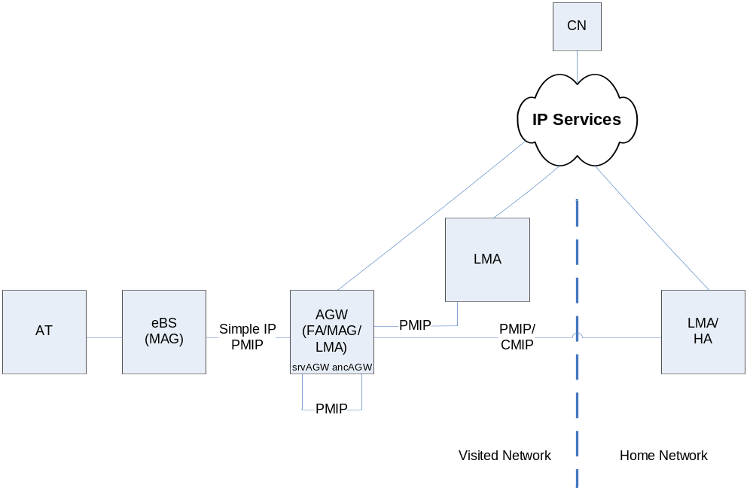

Figure 2 – 3GPP2 Converged Access Network Architecture IP Mobility Flow

Simple IPv4
Simple IPv4 may be operated in a local environment between the AT and AGW [3GPP2 X.S0054-100-0]. In this case the AGW acts as either as a DHCPv4 relay agent or DHCPv4 server. The identifier for the the AT is its Network Access Identifier [RFC 4282]. In this case the CN only needs to know the NAI of the AT to reach it via the AGW.

Simple IPv6
Simple IPv6 operates in a similar fashon to Simple IPv4 [3GPP2 X.S0054-100-0]. In this case the AGW acts as either a DHCPv6 relay agent or stateless DHCPv6 server.

Simple IPv4 and PMIP
Simple IPv4 may operate with PMIP where the AGW operates as a MAG to an LMA in the visited network or to an LMA in the home network. PMIP4 is run between the MAG and LMA in either case. This scenario is described in [3GPP2 X.S0054-220-0].

Simple IPv6 and PMIP
Simple IPv6 may likewise operate with PMIP where the AGW operates as a MAG to an LMA in the visited network or to an LMA in the home network. Note however that PMIP4 is again run between the MAG and LMA in either case as described in [3GPP2 X.S0054-220-0]. This interface uses the dual stack mobile IPv4 approach [mip4-dsmipv4].

PMIP and CMIP
PMIP may operate with CMIP where the eBS operates as a MAG to an AGW operating as an LMA in the visited network. The AGW also operates as a Foreign Agent (FA) running CMIP with the HA. This scenario is described in [3GPP2 X.S0054-210-0].

3.2 3GPP2 Interworking with non-3GPP2 Networks

Figure 3 depicts 3GPP2 interworking with non-3GPP2 networks.

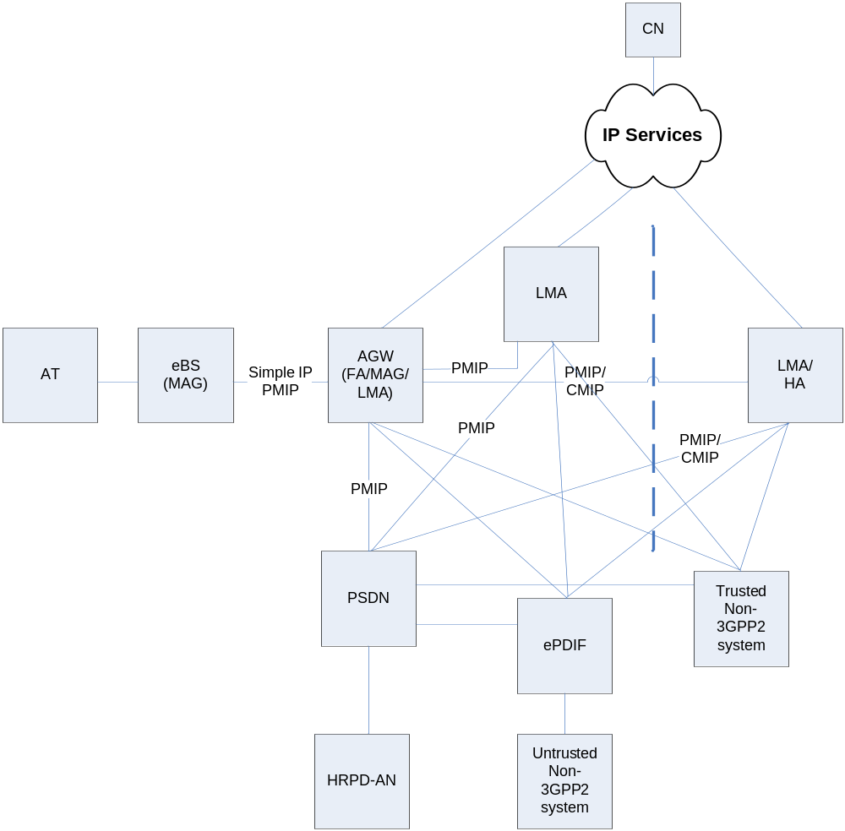

Figure 3 – 3GPP2 Interworking with non-3GPP2 Networks

HRPD Access Network Interworking

The legacy High Rate Packet Data access network interfaces to the CAN core through the Packet Data Serving Node (PDSN) from the CDMA-2000 environment. The PDSN will interface to a CAN element with LMA functionality using PMIP. The PDSN will interface to a CAN HA using CMIP.

Non-3GPP2 System Interworking

Non-3GPP2 systems may be trusted or untrusted. Untrusted non-3GPP2 systems interwork with the CAN through a enhanced Packet Data Interworking Function (ePDIF). The details of this interworking have not yet been defined,

4. REFERENCES

[3GPP TR 23.882] 3GPP System Architecture Evolution: Report on Technical Options and Conclusions (Release 7)

[3GPP TS 23.402] 3GPP Technical Specification Group Services and System Aspects: Architecture enhancements for non-3GPP accesses
(Release 8)

[3GPP2 X.S0054-000-0]
3GPP2 CAN Wireless IP Network Overview and List of Parts,
December 2007

[3GPP2 X.S0054-100-0]
3GPP2 Basic IP Service for Converged Access Network Specification, December 2007

[3GPP2 X.S0054-210-0]
3GPP2 CMIP based Inter-AGW Handoff, December 2007

[3GPP2 X.S0054-220-0]
3GPP2 Network PMIP Support, December 2007

[global-haha] P. Thubert et al., Global HA to HA protocol, draft-
thubert-nemo-global-haha-02.txt, September 2006

[mip4-dsmipv4] G. Tsirtsis et al., Dual Stack Mobile IPv4, draft-ietf-mip4-
dsmipv4-06.txt, February 2008

[mip4-proxy-mode] K. Leung et al., WiMAX Forum/3GPP2 Proxy Mobile IPv4,
draft-leung-mip4-proxy-mode-07.txt, February 2008

[netlmm-mip-interactions]
G. Giaretta, Ed., Interactions between PMIPv6 and MIPv6:
scenarios and related issues, draft-giaretta-netlmm-mip-
interactions-02.txt, November 2007

[proxymip6] D. Gundavelli, Ed., Proxy Mobile IPv6, draft-ietf-netlmm-
proxymip6-11.txt, February 2008

[reg-tunnel] E. Gustafsson et al., Mobile IPv4 Regional Registration,
draft-ietf-mobileip-reg-tunnel-09.txt, June 2004

[RFC 3344] C. Perkins, Ed., IP Mobility Support for IPv4, RFC 3344,
August 2002

[RFC 3775] D. Johnson et al., Mobility Support in IPv6, RFC 3775,
June 2004

[RFC 4140] H. Soliman et al., Heirarchical Mobile IPv6 Mobility
Management (HMIPv6), RFC 4140, August 2005

[RFC 4282] B. Aboba et al., The Network Access Identifier, RFC 4282,
December 2005

